Predicting Malignant vs. Benign Breast Tumors from Cell Nuclei Features
CSE 437: Data Science - Coding With Real World Data
Group Number: 10
Members: Samin Safwan (23301388), Naim Mahmud Peyas (22301646), Waess Karnee (23301454)

Goal of the Project
This project builds a full data science pipeline on real biological data, tied to our thesis area of bioinformatics. We use measurements taken from cell nuclei in breast tumor biopsy images to sort tumors into malignant or benign. Building a working classifier is only part of the assignment we also had to show the whole pipeline the course asks for: cleaning the data, exploring it, running hypothesis tests, reducing dimensionality to engineer features, and comparing multiple ML models against each other

Materials and Method
Dataset: Breast Cancer Wisconsin (Diagnostic) Data Set. https://www.kaggle.com/datasets/uciml/breast-cancer-wisconsin-data
Colab file link: CSE437_Project.ipynb
The dataset has 569 samples from Fine Needle Aspiration (FNA) biopsies of breast masses. Each sample records 10 characteristics of the cell nuclei visible in the digitized image : radius, texture, perimeter, area, smoothness, compactness, concavity, concave points, symmetry, and fractal dimension; and each of these is summarized three ways (mean, standard error, and "worst"/largest value), giving 30 numeric features total. Every sample is labeled Malignant (M) or Benign (B) based on pathologist confirmation. The split is 357 benign and 212 malignant.
Data Preprocessing:
• Dropped the 'id' column (not informative) and 'Unnamed: 32' (an empty artifact column).
• Encoded diagnosis as a binary target. Malignant = 1, Benign = 0.
• Checked data integrity: no missing values, no duplicate rows.
• Standardized all 30 features with StandardScaler, since the raw scales were wildly different (area_mean reaches into the thousands while smoothness_mean stays under 0.2)
Exploratory Data Analysis and Statistical Testing:
Histograms of the key features (radius_mean, texture_mean, concavity_mean, area_mean), split by diagnosis, showed clearly separated distributions between benign and malignant; radius, area, and concavity gave the cleanest split. A correlation heatmap over all 30 features showed heavy multicollinearity among the size-related ones, since radius, perimeter, and area all move together across mean, SE, and worst variants; this is what pushed us toward dimensionality reduction. Boxplots backed up the same separation pattern and flagged a handful of outliers, which we kept rather than treated as errors, since they looked like genuine biological variation. Independent two-sample t-tests confirmed the benign/malignant differences were statistically significant across every feature tested (p < 0.001 in all cases; radius_mean came out at p = 8.47 × 10-96).

Feature Engineering (PCA):
We ran PCA on the standardized variables to cut down dimensionality. The cumulative explained variance plot showed that 10 principal components hold onto about 95% of the variability in the original 30, so we transformed the dataset down to those 10 components.

Machine Learning Architectures:
We split the PCA reduced dataset into training and test sets (80/20, stratified by class) and trained three classifiers: Logistic Regression, Decision Tree, and Random Forest; all with scikit-learn's default parameters

Full Workflow / Pipeline:
• Load raw data → clean (drop columns, encode label, check missing/duplicates)
• Descriptive statistics → EDA (histograms, correlation heatmap, boxplots)
• Statistical testing (independent t-tests between classes)
• Feature scaling (StandardScaler) → dimensionality reduction (PCA, 30 → 10 features)
• Train/test split (80/20, stratified) → train models (Logistic Regression, Decision Tree, Random Forest)
• Evaluate and compare models (accuracy, precision, recall, F1-score, confusion matrix)

Results
The table below summarizes the overall accuracy of the three classification models on the held out test set (114 samples).
Model | Accuracy
Logistic Regression | 98.25%
Decision Tree | 92.11%
Random Forest | 93.86%
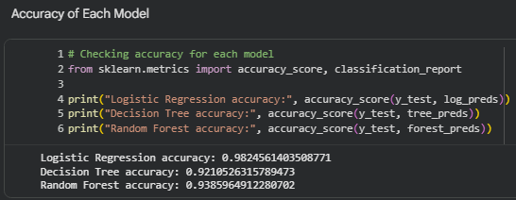
Logistic Regression came out on top, followed by Random Forest, with Decision Tree trailing behind. That tracks decision trees tend to overfit more easily than the other two, especially on a dataset that's fairly linearly separable to begin with.

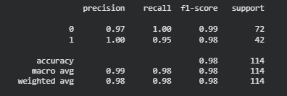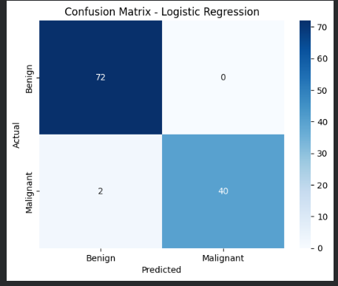
Logistic Regression hit a precision of 1.00 and recall of 0.95 for the malignant class (F1 = 0.98), and precision of 0.97 with recall of 1.00 for benign (F1 = 0.99). The confusion matrix shows all 72 benign cases classified correctly with zero false alarms, and 40 out of 42 malignant cases caught correctly; just 2 malignant cases slipped through as false negatives. That matters clinically: a false negative here means a missed cancer diagnosis, so even at 98% accuracy, perfect sensitivity wasn't reached.
Overall, the PCA condensed representation of cell nuclei shape carries enough signal to classify tumors accurately, and on this dataset, the linear model (Logistic Regression) edges out the tree based approaches.

